Building New Project

Use the nugget package to download the

1: selenium support

2: selenium web driver

It is better to declare the Iwebdriver in the [TestClass] 🡪 as a property and not as a field

Example: private IWebDriver Driver { get; set; }

And then 🡪

Driver = GetChromeDriver();

And we have to download the chrome driver from the internet and copy it to the project forder see the screenshot:

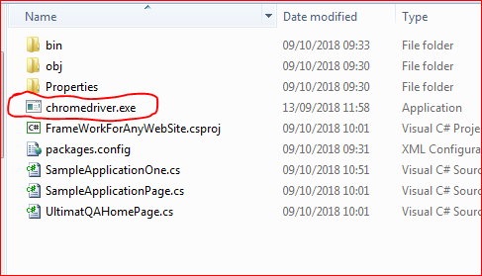

After that to add to the project 🡪right click on the project name 🡪add

🡪existing items 🡪select the chromedriver.exe🡪make sure that the file

Was added to the project see the screenshot :

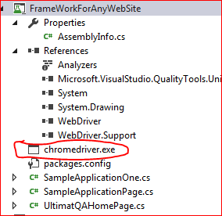

Then you can reference it by this function

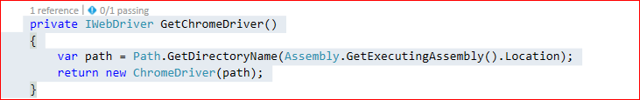

Note Using Properties is very important the developer can see the references

Example :if we have a method like that

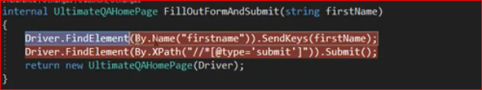

We can refactor it by using properties🡪 see screenshot below

Generating the properties like that

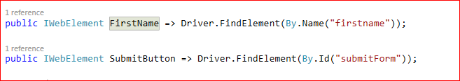

And then using them in the function 🡪see screenshot

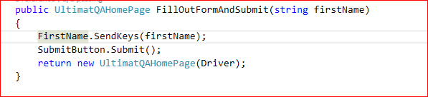

After that we should compare our class to see if there is a code duplication 🡪 if so we have to create a base class that will contains all the common code and then to inherit from it :

See screenshots:

This is the base class

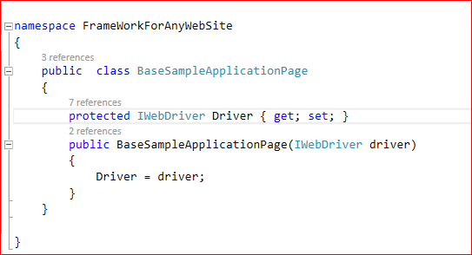

Derived classes

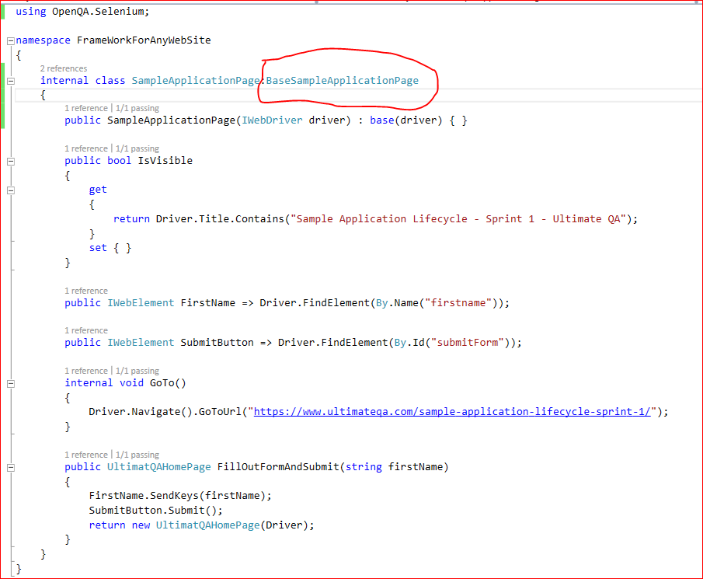

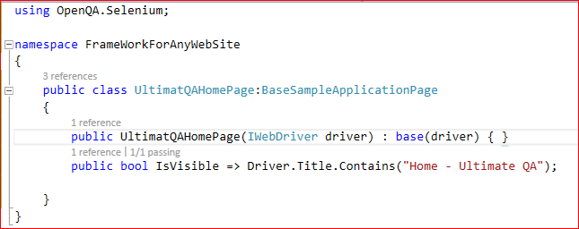

Code Map Diagram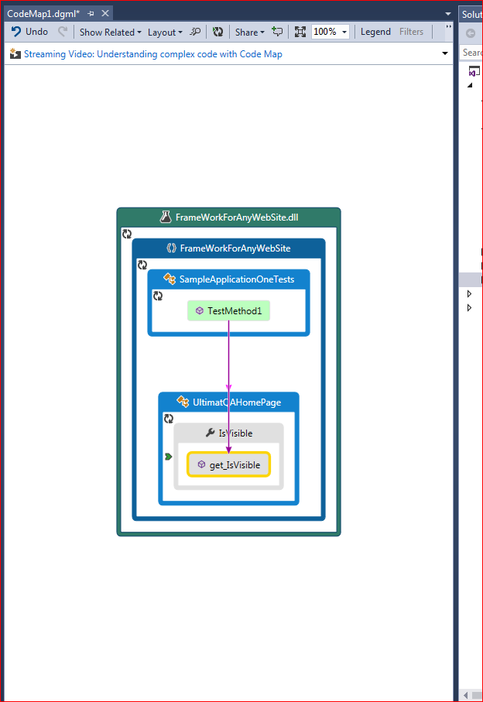

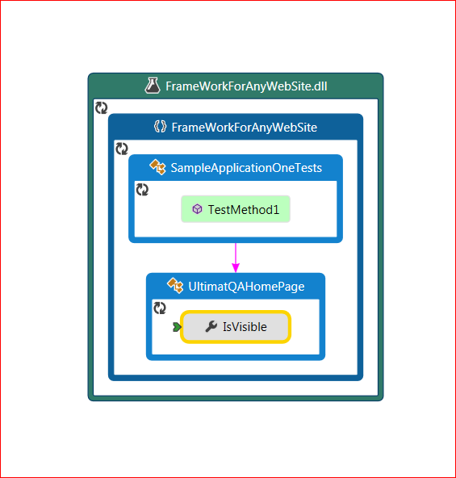

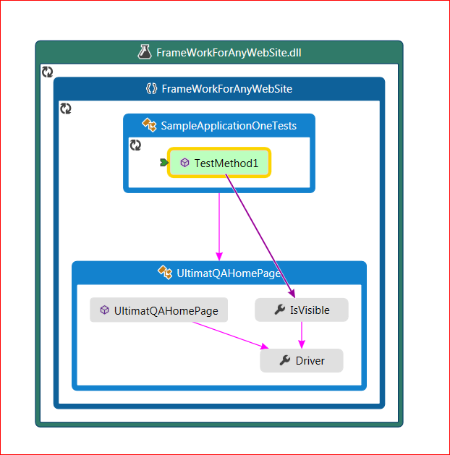

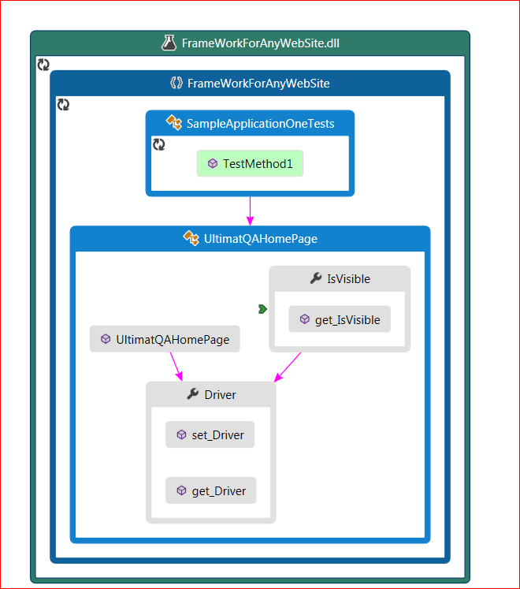

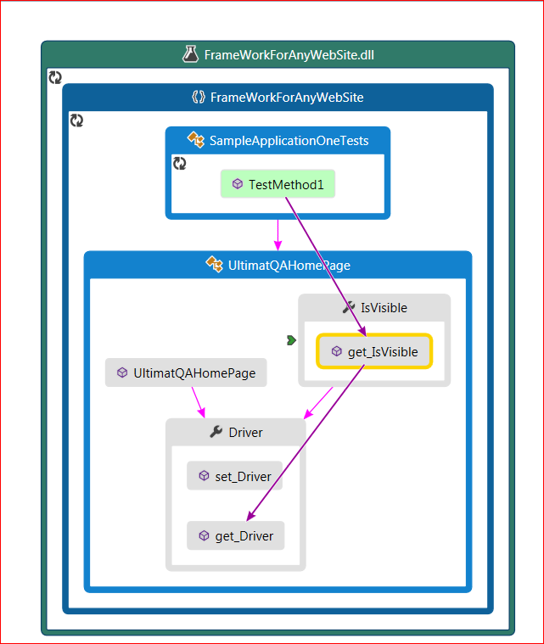

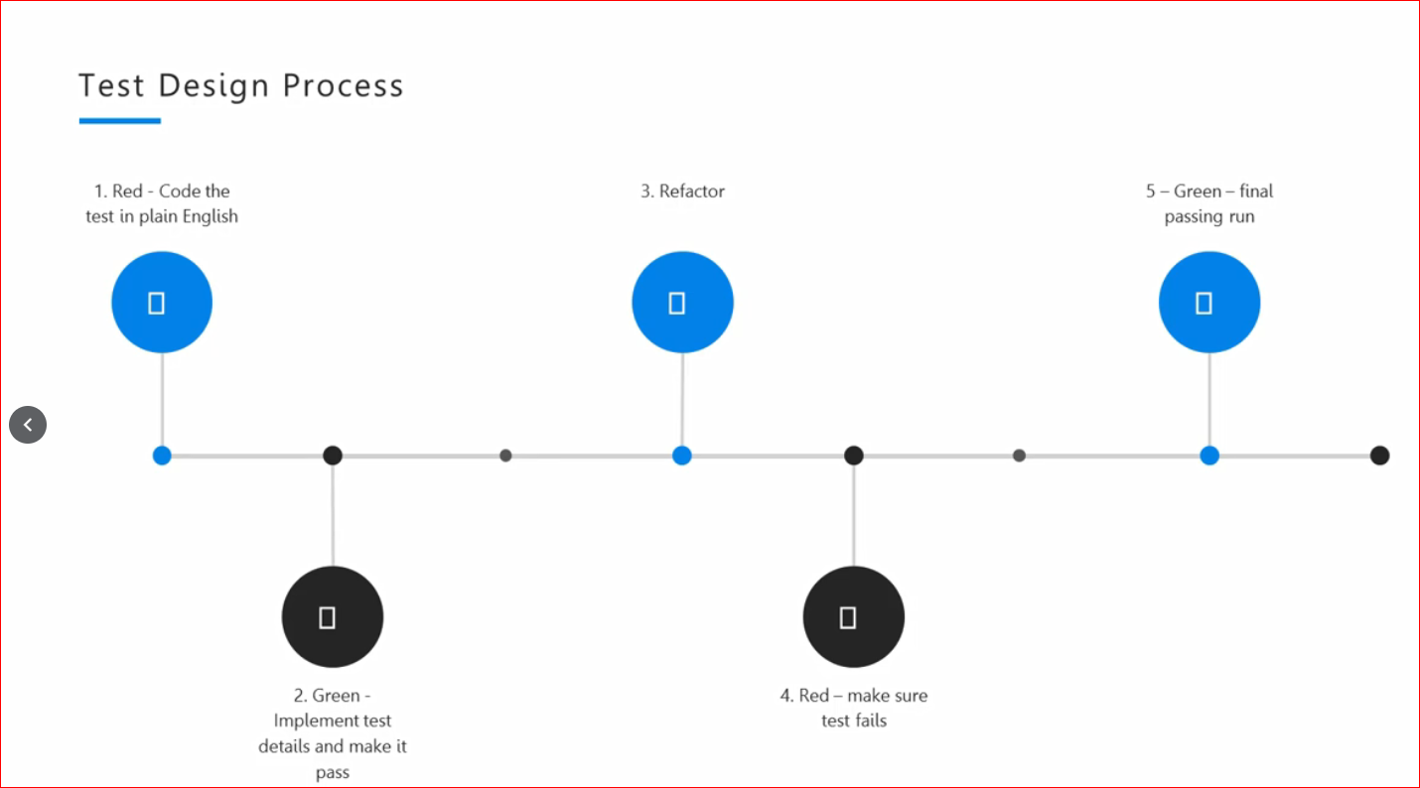

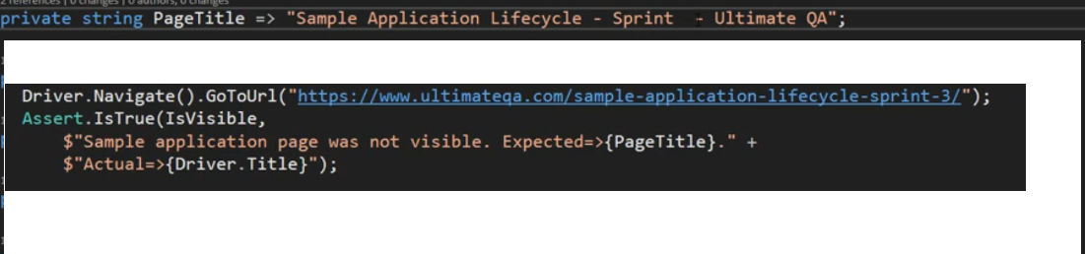

Tests Organization

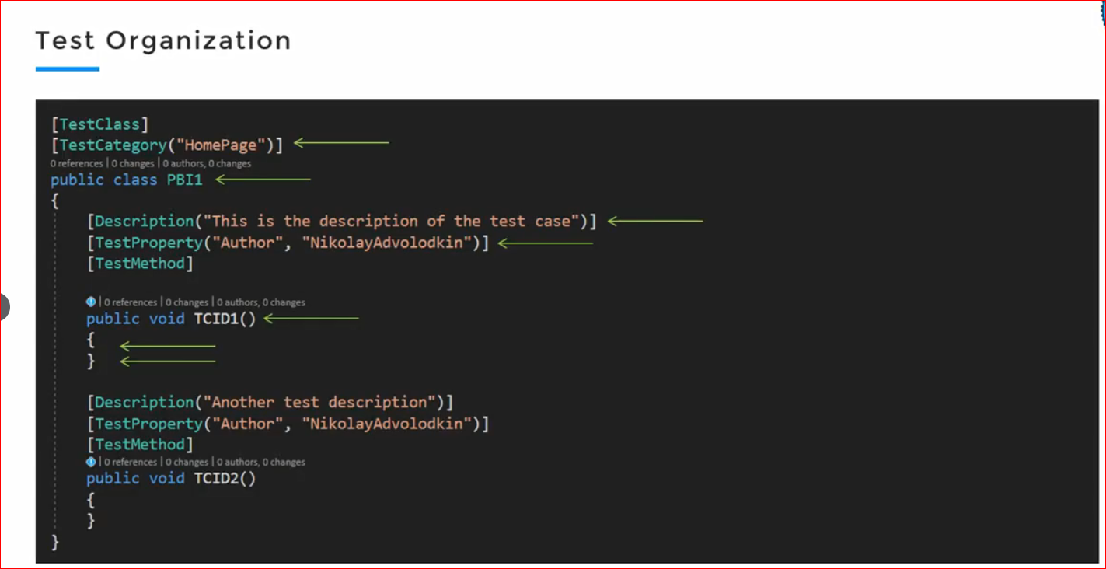

PBI 🡪 Product Backlog Items

Test class is a PBI or a User Story

Test Methods Are Test Cases

Creation a Test case from scratch

Example to automate this website

<http://automationpractice.com/>

Search the string blouse

Click search button

1: create the instance of the web page (using the TDD approach)

2: Kind of assertion:

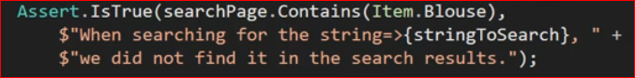

3: example for TDD 🡪How it should look like

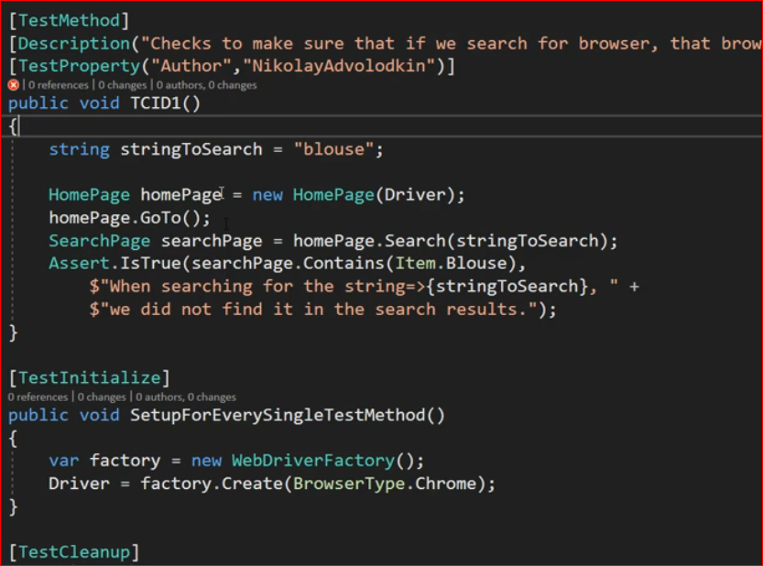



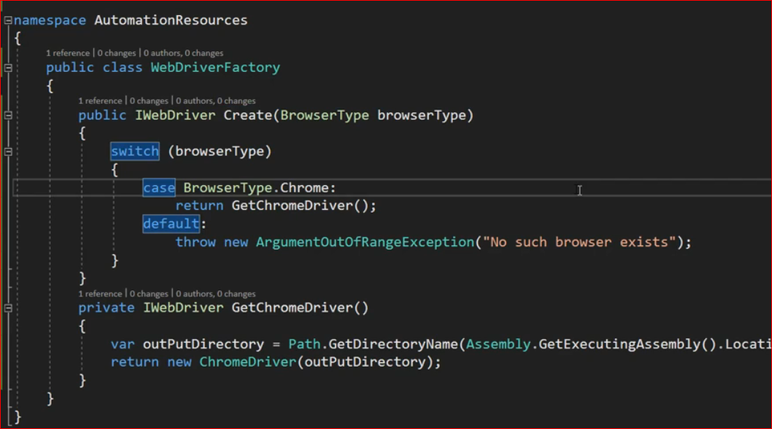

1: it follows the factory design pattern

2: here in this class is the single place where Web driver will instantiate

3: [Test initialize] will call the method to create the instance of the driver

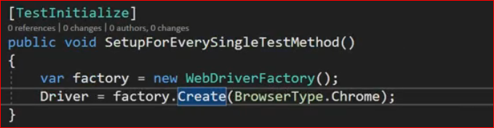

4: putting all the global resources of the project in one place in the solution

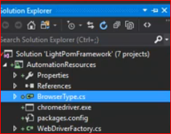

5: Note the class name is the “Test Story “so make it Readable and describes the story

6: example

If we want to validate a contact page

First of all we have to create an instance from this page as follows



7: one way to check if a page was loaded

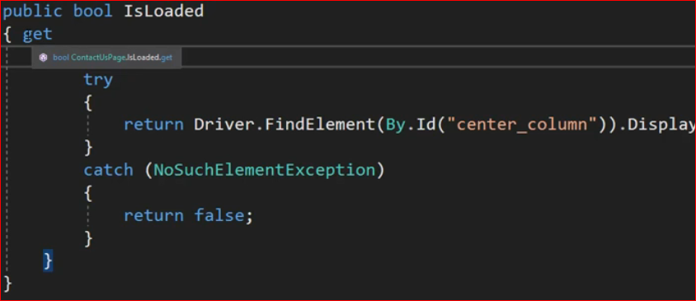

8: Contact page

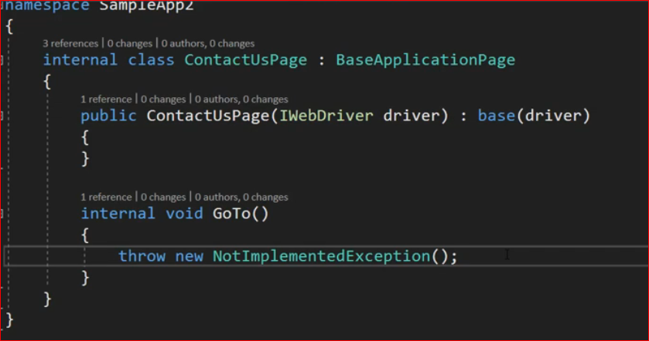

9: the all test method

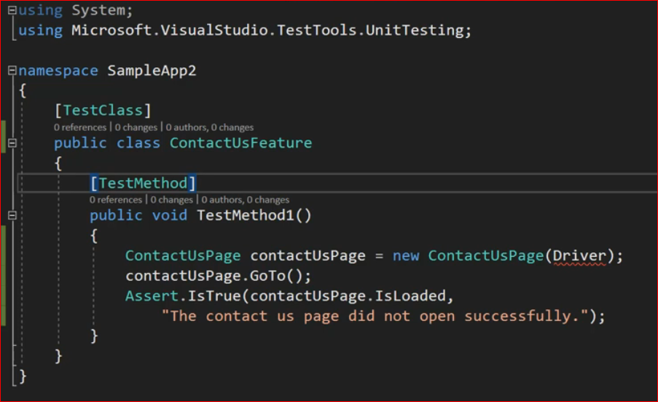

Create Base Test Class

Contains all the common functionality 🡪 like the

1: [Test Initialize]

2: [Test Cleanup]

3: Create a property for the web browser

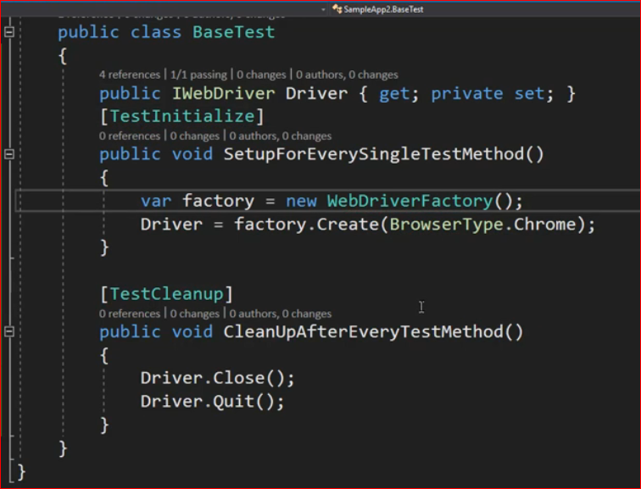

The Test using the Base test class

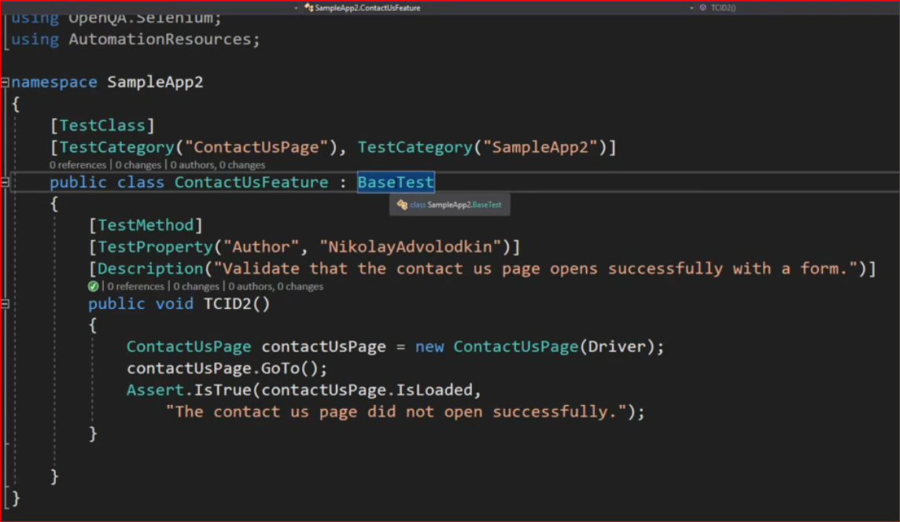

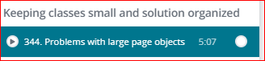

Breaking the page 🡪into pieces 🡪other pages and handling each one individually

For example if in our page we have “Slider” section we can create POM named “Slider” 🡪 by using the

Home page constructor

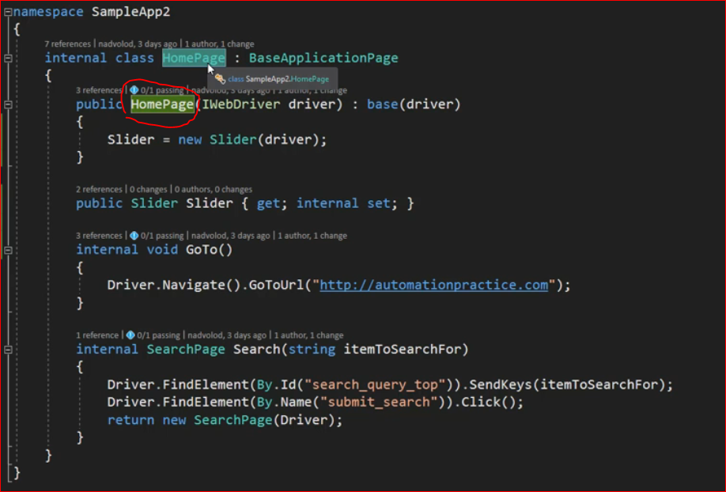

Just declare a property in the home page constructor 🡪 see screenshot

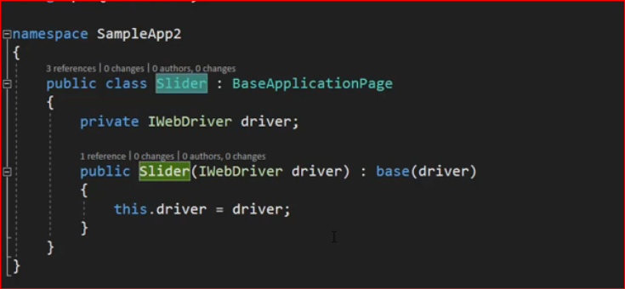

Various examples



The page sections

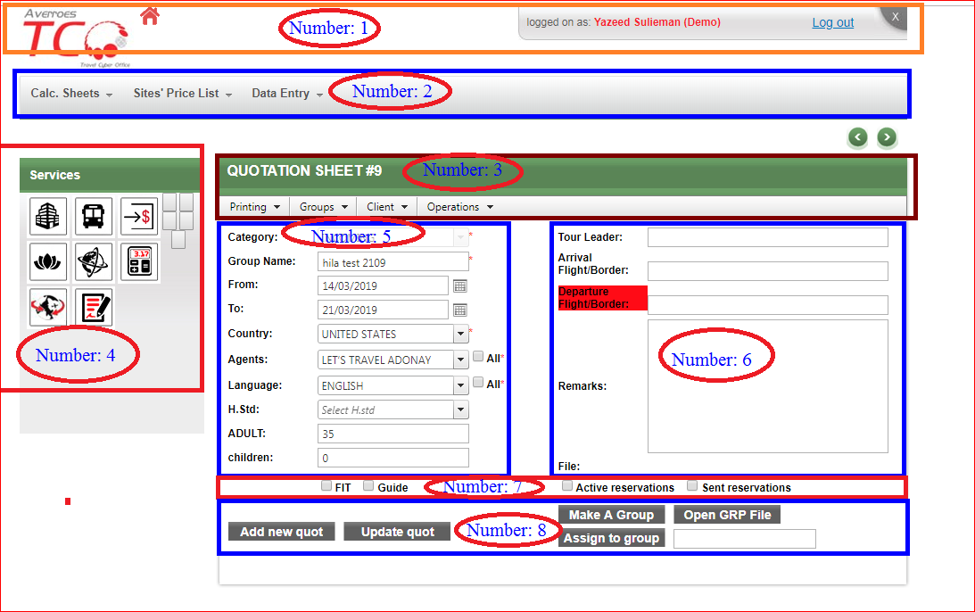

Examples about explicit wait

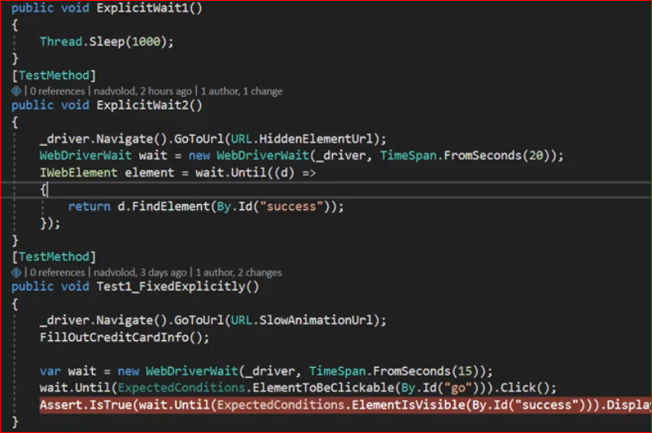

Logs

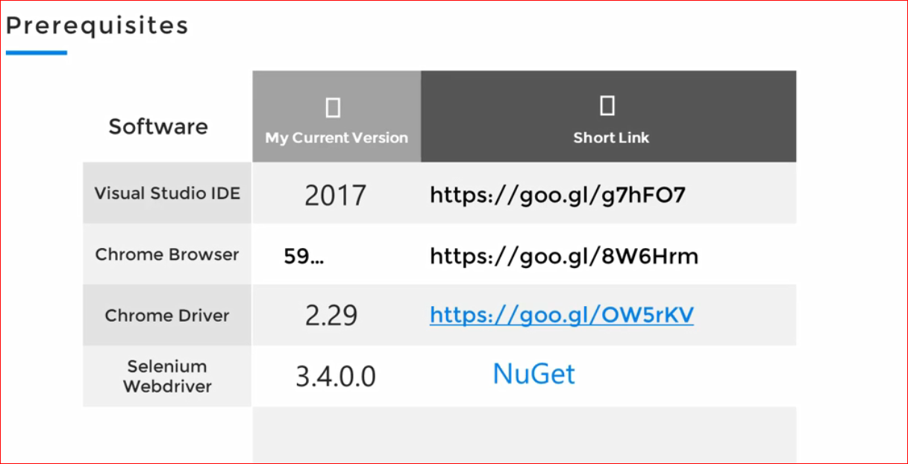

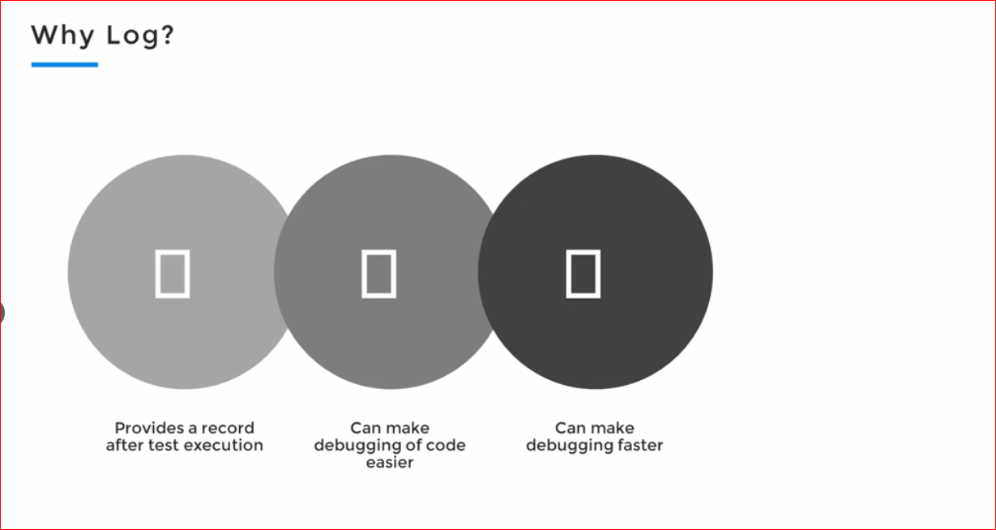

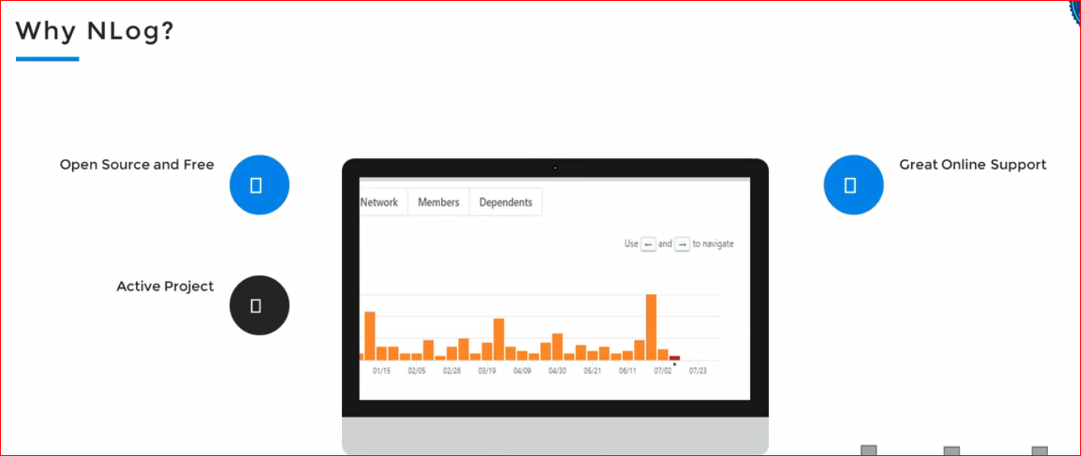

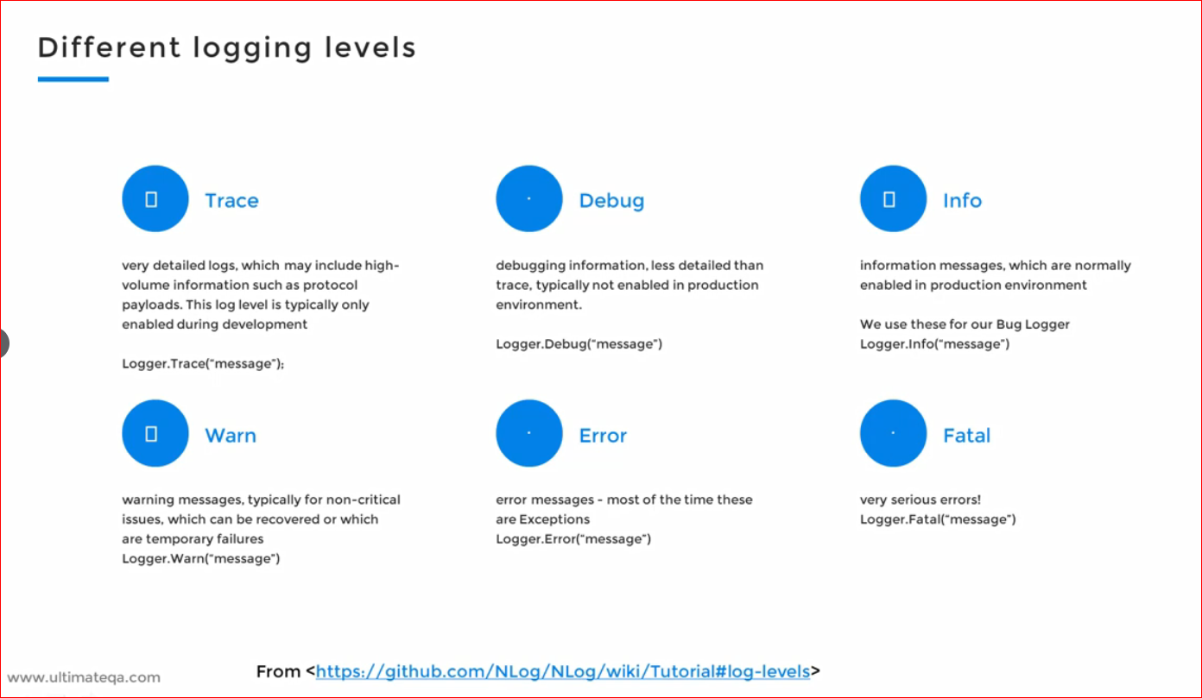

Notes: we have to create an instance of the Nlog for every single class to be able to log

The behaviors

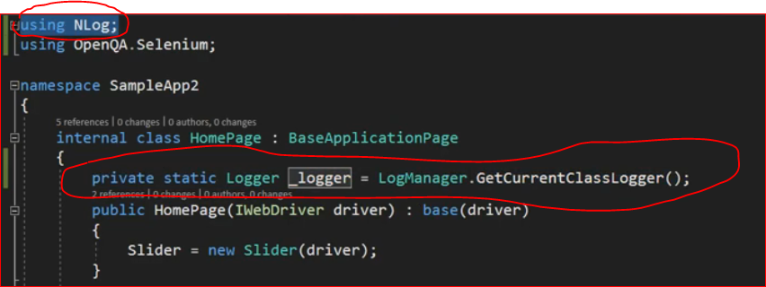

The logger object should be only in the page object (POM)

Reports

We are using extent reports

Extent report is an open source system

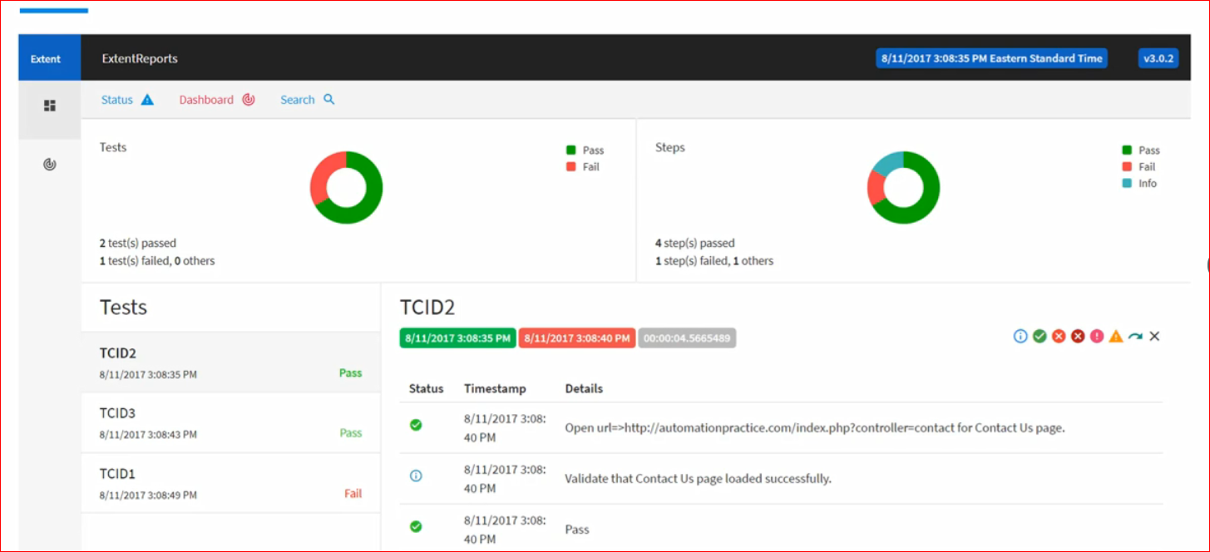

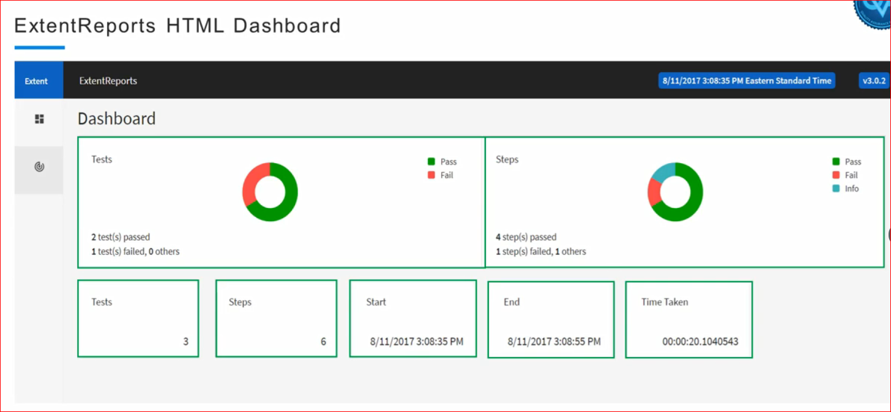

In order to create an extent report we have to create objects from the

ExtenthtmlReporter🡪 see screenshots

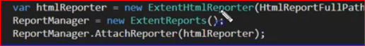

Diagram example

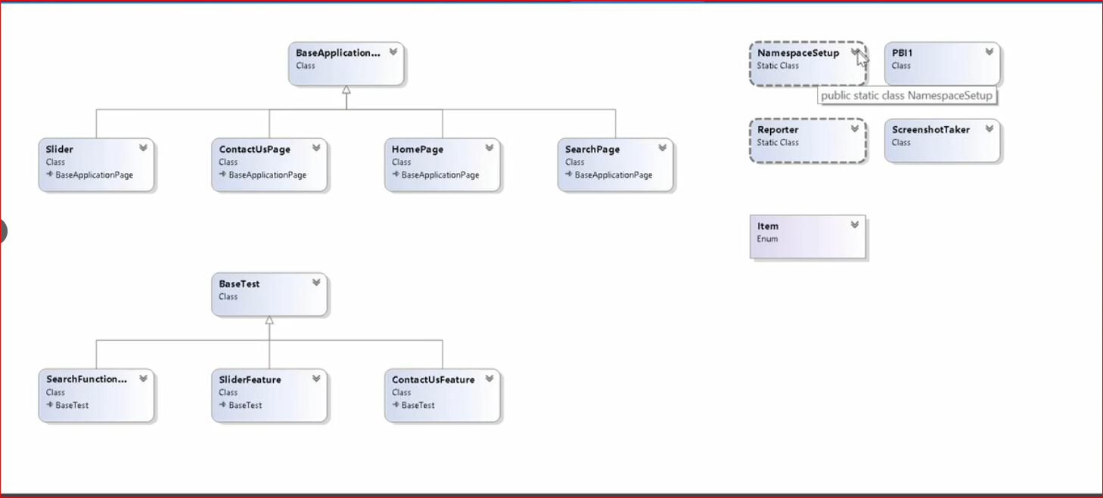

How to create the extent report

Creating the html reporter🡪 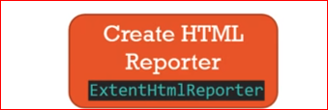

And then attach it to 🡪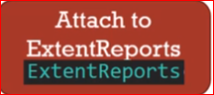

Then the creating some features by using 🡪 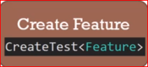

And creating some scenarios 🡪 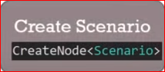

So this is the pseudo code

